**Algorithms**

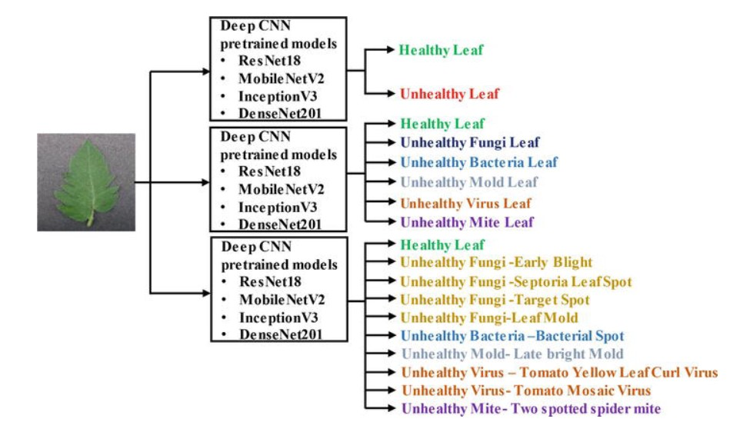**Deep learning** is a branch of artificial intelligence. In recent years, with the advantages of feature extraction. It has been widely used in image and video processing, voice processing, and natural language processing. At the same time, it has also become a research hotspot in the field of agricultural plant protection, such as plant disease recognition and pest range assessment. The application of deep learning in plant disease recognition can avoid the disadvantages caused by artificial selection of disease spot features, make plant disease feature extraction more objective, and improve the research efficiency and technology transformation speed.

In the initial step, the RGB images of all the leaf samples were picked up.

The step-by-step procedure of the proposed system:

* RGB image acquisition
* Convert the input image from RGB to HSI format
* Masking the green pixels.
* Removal of masked green pixels
* Segment the components
* Obtain useful segments
* Evaluating feature parameters for classification.
* Configuring SVM for disease detection.

**Colour Transformation:** HSI (hue, saturation, intensity) colour model is a popular colour model because it is based on human perception. After transformation, only the H (hue) component of HSI colour space is considered since it provides us with the required information.

**Masking Green Pixels:** This is performed as green colour pixel represent the healthy region of a leaf. Green pixels are masked based on the specified threshold values.

**Segmentation:** The infected portion of the leaf is extracted by segmenting the diseased part with other similar coloured parts (say, a brown coloured branch of a leaf that may look like the disease) which have been considered in the masked-out image, are filtered here. All further image processing is done over a region of interest (ROI) defined at this stage.

**Classification:** From the previous results we analyse and evaluate the features like the area of the leaf, percentage (%) of the leaf infected, the perimeter of the leaf, etc., for all the leaf images, and pass it to the SVM classifier.